360° Smart Moti on
Tracking Camera
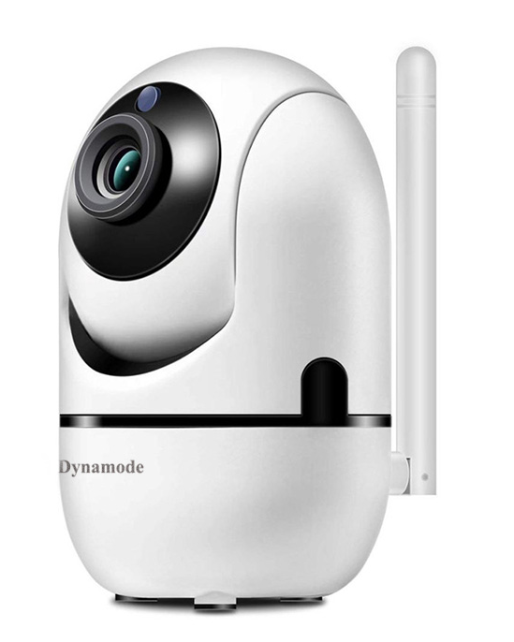
CAM-811

Features:
- 2 MP 1/3" low illumination CMOS sensor;Advanced 28NM process with lower power
consumption, higher stability, higher reliability; 1080P Resolution, the image is
clear and delicate;
- HD Lens 3.6mm@F2.0:
- ICR automatically switches to achieve day and night monitoring; Automatic electronic
shutter to adapt to different monitoring environments; Infrared distance: 6
high-power LED lights 8 meters ~ 15 meters;
- Support digital wide dynamic, 3D noise reduction;
- H.265 AI video compression technology, high image quality, low bit rate; Support mobile
phone remote monitoring (iOS, Android)；Multi-browser access (IE、Chrome、Firefox、
Safari)；
- Support information overlay (such as ID, IP, DDNS information, etc.); Supporting WEB,
- CMS, VMS, MYEYE, cloud services;
- Supports interfacing with HVR/NVR and supports the standard Onvif protocol.

Specification
Camera | Model No. | CAM-811
 | Sensor | 1080P 1/3" Low illumination CMOS sensor
 | Low illumination | Color： 0.01Lux @(F1.2,AGC ON); 0 Lux with IR
 |  | B/W： 0.001 Lux @ (F1.2,AGC ON),0 Lux with IR
 | shutter | 1/50(1/60)s to 1/10,000s
 | Lens | HD Lens 3.6mm@F2.0
 | Lens interface | M12
 | Day Night | Support IR-CUT
 | Max. Size | 1280*1080
Image | FPS | PAL: 1080P@25fp
 |  | NTSC: 1080P@30fps
 | Settings | Saturation, brightness, contrast adjustable
 | Standard | H.264X/H2.65AI Video coding compression
Compres sion standard | output bit rate | 0.1Mbps~4Mbps
 | Audio compression standard | G711a
 | Storage function | Network Storage; Support SD Card Max.128g
Network features | Intelligent alarm | Motion detection, video loss, network cable break, IP address conflict
 | Protocol | Wi-Fi wireless transmission (supports IEEE802.11b/g wireless protocol)
 | General function | Anti-flicker, dual stream, heartbeat, password protection
 | Audio I/0 | Built-in speaker
 | Operating temperature | -10℃-＋ 60℃
 | Working humidity | 10%-90% RH
 | Power | DC5V±10%
General | Infrared distance | 6 LED lights "IR1": 8-15 meters;
 | Power consumption | MAX 3W
 | Protection | N/A
 | Net Weight | Around 310g
 | Size

